Practical No.2 Name: Bilal patel
Aim: To study types of variables and methods, passing class members, Inheritance , and constructors in inheritance.
1. Types of variables in python OOP:
Static variable, Instance variable, and Local variable
Input:
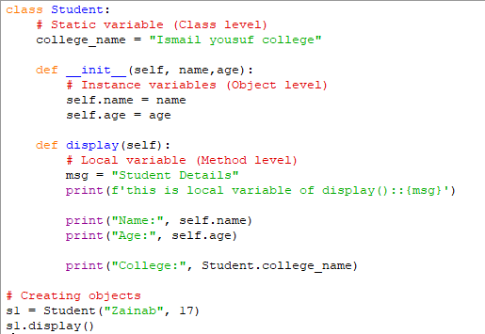
Output:
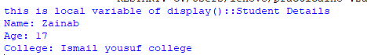
2. Types of Methods in python OOP:
A) Instance Method

Input:
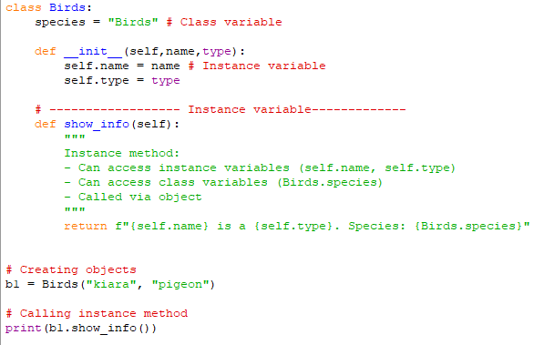
Output:
B) Class Method
Input:
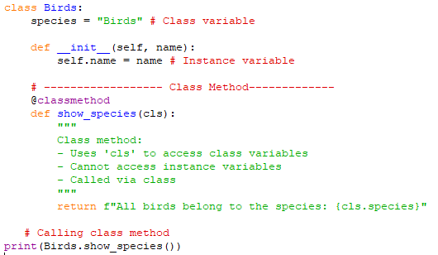
Output:
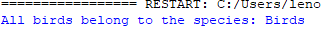
C) Static Method
Input:
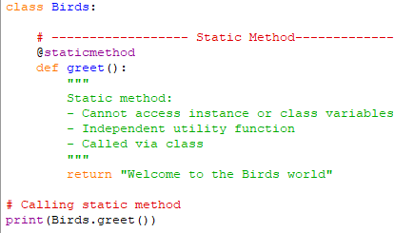
Output:
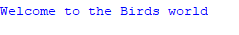
3. Passing class members between classes
Input:
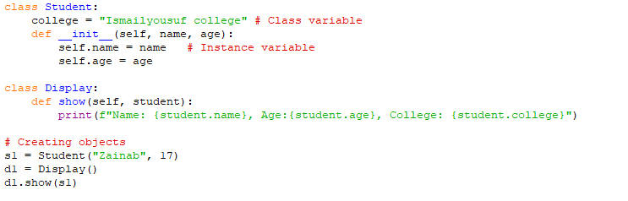
Output:
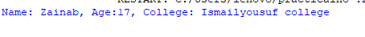

4. Inheritance:
Single Inheritance:
Input:
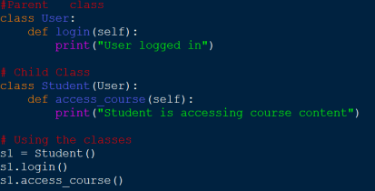
Output:
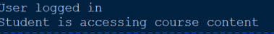

Multiple inheritance:
Input :
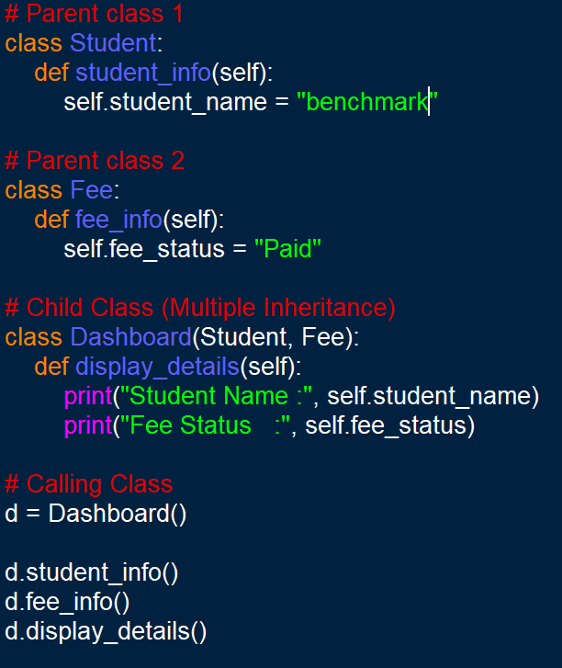
OUTPUT:


Multilevel inheritance:
Input:
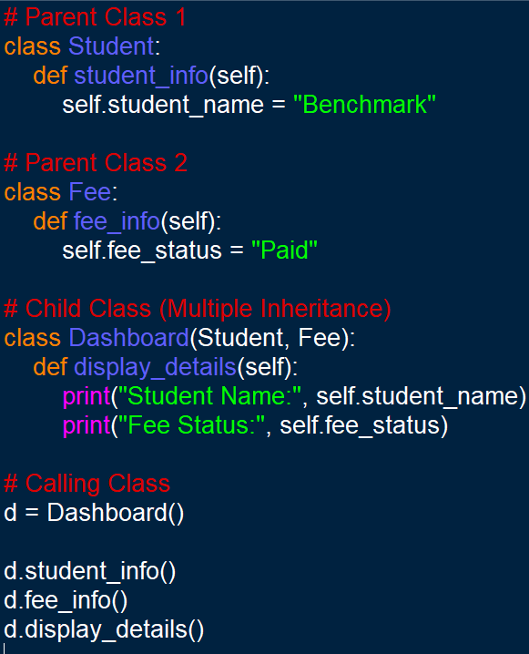
Output:


